Dominant frames (topics evoked during peaks of engagement)

In the previous parts, we focused on the popular hashtags within the BLM ecosystem, compared them and analyzed the narratives they brought, which was part of our general“frame analysis” process. Frame analysis is a social science research method that focuses on how a topic is represented through the specific issues and sub-topics that people focus on, and how actors may exert an influence on this selection process. Framing mechanisms are a key mobilization process when it comes to social movements. Indeed, they “*assign meaning to and interpret relevant events and conditions in ways that are intended to mobilize potential adherents and constituents, to garner bystander support, and to demobilize antagonists*” (Snow & Benford, 1988). It is a conscious and unconscious process. Collective action frames involve “*negotiating shared meaning*” (Gamson, 1992) which allow movements to ‘*legitimize their actions, create a sense of collective identity and inspire support, characterize messages in ways that resonate with the public’* (Wenlin Liu, Summer Harlow, 2020). Social media is a strong diffusion mechanism for spreading those social movement frames and strategies, allowing both a relational and a mediated model of diffusion; platforms such as twitter facilitate frame alignment, which Snow and Benford define as the alignment of individual frames in congruency and complementariness. This frame alignment produces frame resonance, which in turn helps a group transition from one frame to another.

We chose to focus on the peaks of engagement for the popular #BLM and #Defundthepolice hashtags (volume of tweets) in order to identify the main frame alignments on Twitter during these time periods during which the movement was the most visible. What topics generated the most engagement? Was there any discrepancy between the frames of the most popular tweets, and the frames that were the most discussed? Did the movement transition from one dominant frame to another during or between peaks? For #defund the police, the time periods we identified were the first three weeks of our corpus (2020.05.28, 2020.06.06, 2020.06.15); #blacklives matter had several bigger peaks at the same time (same weeks, with a massive peak of engagement on 2020.06.02) and a smaller peak between 2020.08.24 and 2020.08.27.

In order to simplify the analysis, we adopted the three kinds of frames conceptualized by Snow and Benford: first, diagnostic framing, which states the problem (generally in Manichean terms), identifies victims, assigns blame (“X killed Y”, “X is racist”). Secondly, prognostic framing, which offers solutions and how they could be implemented (“A should do B”). Finally, motivational framing is more of a call to arms that legitimizes the movement (principles) and spreads action-oriented leitmotivs related to what people should do if they agree with the diagnostic frame and the prognostic frame (for example, “vote A”, “contact B”…)

First, using the open source, web-based application Voyant Tools made for text mining, we decided to identify the main topics of the top 20 tweets during the first week, for the BLM hashtag.

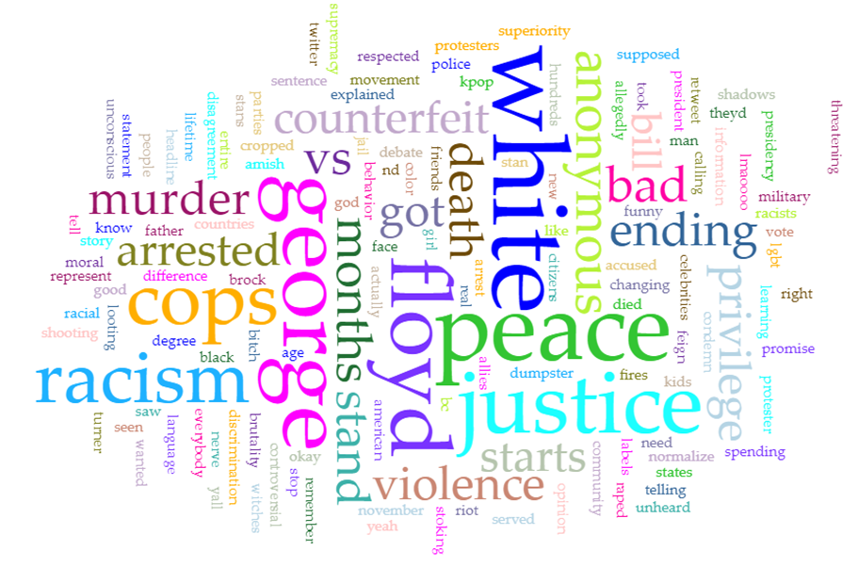

Then, we created a simplified network visualization of the most frequent word associations of the top 20 tweets of week 1 (BLM). As expected, they were related to diagnostic framing; explaining the circumstances of George Floyd’s death and the crux of the problem for the BLM movement: “racism”, “white privilege”, a call for “justice” and “ending violence”. (*Side note, the “batman” wildcard is related to a man that came to a protest dressed up as Batman and generated a lot of RTs, but we also noticed people using it both to say things along the lines of “we need batman” and as a derogatory way to call policemen “racist vigilantes”).

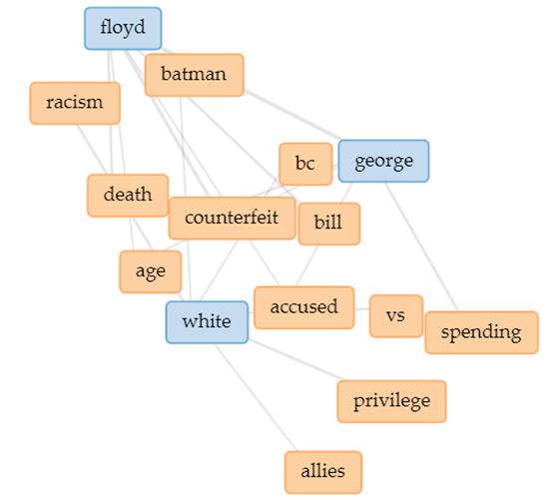

Meanwhile, the analysis of the top 20 most popular #defundthepolice hashtags during Week 1 produced more prognostic oriented results and had more precise targets when it came to diagnosing the situation and assigning blame (denouncing how education had been defunded but not the police, pointing out specific departments/city councils/mayors) and was also more directly linked to the protests (“protesters”, “tear gas”, “transit/traffic” issues, “medics”).

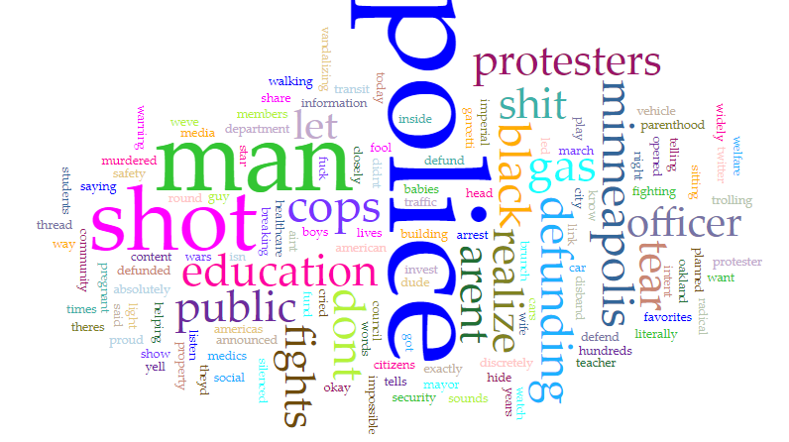

Using TF-IDF we drew out the most frequent words of the most popular tweets during each peak, and the most frequent words in general during in peak, and ran a comparative analysis.

The data:

#Blacklivesmatter data: most frequently used words over the 4 main peaks (most popular tweets)

|  |  |  |  |  |
| --- | --- | --- | --- | --- |
| issued known challenge men color to arms paper recruited free blacks including sons lewis charles memorial valor watch white woman black man the weaponizing white fragility itself game it lead black death sometimes karen indifferent truth at times like this appears intentional this terrify. | more than just an athlete, this probably impactful picture i taken , youre waiting someone step up speak shape change you someone , they rejected recruiters wwi they fought fight country thought equal they prevailed they called best kept military secret remember rejection fight remember | is sheep preaching hate says im going let wolf eat anymore denzel washington 1992 , keep momentum endurance lets continue pressure issues equality black people police brutality sexual violence how better appreciate black women covid, black lives matter , just like trump blocking, available fre | historic change requires historic turnout our ballots represent vote voice phase protest tool help craft tomorrow ,u s code1701 obstruction mails generallywhoever knowingly willfully obstructs retards passage mail carrier conveyance carrying mail shall fined title imprisoned months both | maliyah bass mother boyfriend returned apartment today neighbors extremely worked up some held attacking two ultimately neighbors questioning happened year old girl ,and yall wonder police someone tell wtf this exactly black man targeted this shit wrong sad feel sorry him family our people we |

#Defund the Police, Top 20 tweets Week 1

|  |
| --- |
| theyd arrest hundreds american citizens own very telling  this dude trolling police star wars imperial march exactly twitter content i today  watch listen closely information man link fund let know absolutely okay silenced  defunding police sounds radical realize realize weve defunding education years  breaking minneapolis city council members announced intent disband minneapolis police department invest community led public safety  thread cops vandalizing property cars media show dont let fool you  this man isn t protester he guy sitting traffic light cops shot car tear gas round he got yell pregnant wife vehicle so opened them  literally walking man theres way u defend shit  they shot black man head shot medics helping him  defund police impossible cried defunded education healthcare social security welfare planned parenthood public transit  police officer tells proud boys to hide inside building because they re about to tear gas protesters the officer said he was warning them discretely because he didnt want protesters to see police play favorites  last night police oakland murdered students babies they shot times i dont words yet except fuck police teacher arent saying too arent fighting us then aint shit  we you mayor garcetti please share widely  americas fights black lives fights brunch |

#Defund the Police data: most frequently used words over the 4 main peaks (most popular tweets)

|  |
| --- |
| lets opportunity push real change entire justice system switch militarized policing de escalation policing body cam turned live streamed publicly end mandatory minimum sentences muzzle police union power,ford cop cars heat interiors degrees kill coronavirus,sure lets tools torture murder |
| m going sharing videos police police shit cw police violence, this exactly state terrorism looks like , philly police attempt disperse crowd hundreds mased gassed parkway this 30 curfew nears dude w white shirt provokes scuffle shoves baton civilians throat , here eye witness account medic shot |
| ccsd going million drop operating funding school yr possibly having deal w social distance learning lvmpd budget 675 589 321why is the idea of defunding the police so radical when u do it to the education system every yr, this i year old white woman mother currently peak karen power went |
| incident confederate monument june police sources conspiracy commit felony injury monument news conference 1 2 , biden listens 75 voters we need medicare all biden i hear you i m busy getting rich blood money insurance companies trumps america this just happened hour ago in kenosha wi cold blooded murder ,arianas instagram story august ,jacob blake icu fighting life he home babies police shot times children mark words going fight accountability hard youre fighting survive home family jacob ,we recent data battleground |

All Tweets: most frequently used words over the peaks

|  |  |  |  |
| --- | --- | --- | --- |
| Week 1  police 0.549295  we 0.  .164075  people 0.156941  city 0.142674  stop 0.114139  budget 0.099872  justice 0.092738  you 0.092738  need 0.092738  black 0.085604  white 0.078471  peaceful 0.078471  to 0.078471  porch 0.074460  know 0.071337  all 0.071337  cops 0.071337  lapd 0.071337  if 0.064203  time 0.064203  officers 0.064203  council 0.061007  protesters 0.057070  them 0.057070  violence 0.057070  lives 0.057070  dtype: float64 | Week 2  police 0.536046  people 0.222859  we 0.186580  cops 0.182137  black 0.154002  it 0.153262  need 0.117723  you 0.109578  like 0.091809  time 0.091069  city 0.091069  officers 0.080703  if 0.072559  dont 0.071078  protest 0.068857  lives 0.067376  today 0.065895  violent 0.064414  budget 0.063674  now 0.062193  curfew 0.062152  new 0.060712  defund 0.060712  all 0.060712  stop 0.059972  man 0.059972  right 0.059232  dtype: float64 | Week 3  police 0.545912  the 0.230325  this 0.204273  people 0.203089  it 0.184734  we 0.172892  need 0.154537  cops 0.130853  you 0.121380  black 0.120787  like 0.109538  budget 0.106577  defund 0.101840  dont 0.088222  want 0.087630  time 0.084078  city 0.075788  if 0.073420  means 0.071644  new 0.071051  now 0.069867  stop 0.068683  all 0.066315  community 0.063946  and 0.063354  support 0.060986  its 0.060986  white 0.060394  that 0.059802  they 0.059802  dtype: float64 | Week 14  police 0.449409  black 0.261704  people 0.250875  kenosha 0.233983  blake 0.228542  this 0.194924  jacob 0.188570  the 0.176876  shot 0.146193  harming 0.145262  stop 0.126340  cops 0.122730  you 0.110096  killing 0.106116  times 0.102257  need 0.099267  it 0.097462  white 0.095657  wisconsin 0.094692  man 0.093853  we 0.092048  and 0.075804  if 0.059560  video 0.057881  like 0.057755  kyle 0.056516  murder 0.055951  rittenhouse 0.054415  they 0.054146  want 0.054146  dtype: float64 |

Rough generalization:

* Main topics (popular tweets) 🡪 George Floyd, tear gas on protesters/medic shot, defunding the police = not so radical, confederate monument, Jacob Blake shot in front of his children
* Main topics (volume) 🡪 [W1] black/white&police (privilege, violence), justice. [W2] more immediate topics (today, protest, curfew), more urgent calls for justice (need/now/no time). [W3]: budget & defund are more frequently used as well as, “support”, community; less frequent use of “white”, the tweets are more oriented on the black community and the need for support & actual reforms. [W14]: more immediate reactions to JB (children, kenosha, wisconsin, but before that: confederate monument debate, money/rich white people ruling US

Week by week comparative analysis between the topics of popular tweets (PT) and the topics in terms of volume (VOL):

Week 1:

* VOL = Diagnostic-oriented 🡪 violence, racism, white privilege, Motivation: save lives, justice
* PT = Prognostic 🡪 opportunity for change, police weapons, switch systems, defund

Week 2:

* VOL and PT = both Diagnostic-oriented -> evidence of violence on protesters, general indignation

Week 3:

* Both VOL. and PT frames are much more prognostic and motivation-oriented: identification of more specific vulnerable group within the black community (black women, disabled black people), identifications of vectors of change (the educational field, the healthcare system), emphasis on the need for support from external actors and on the need to keep the momentum of the movement

Week 14:

* VOL = before Jacob Blake’s death = Prognostic-oriented, motivation-oriented 🡪 broader topics of discussion and more precise suggestions of solutions (healthcare, elections, voters, “Trump’s America”, voting for Biden, black history, education).
* After Jacob Blake’s death (VOL & PT) 🡪 mostly diagnostic-oriented frames about Jacob, his children, the injustice of the situation and the need to hold the policemen accountable

Main conclusions

Following this analysis, we were able to draw some conclusions. First of all, the peaks of engagement of the BLM movement were not necessarily driven by the same motives and did not produce the same kind of frames every time they occurred: we can clearly notice an evolution of the topics that are the most discussed in parallel to the progressive formation and development the movement.

Snow and Benford conceptualized four aspects of frame alignment (bridging, amplification, extension and transformation), that could all be found in our dataset;

* Bridging connects uninvolved individuals with the movement through common interests and goals. In this case, many of the diagnostic-oriented tweets were meant to rally Black people and allies.
* The amplification model is the way a movement expands its core ideas to have a wider, more universal appeal. During the peaks of the BLM and DefundthePolice hashtags, the arguments are extended to encompass the broader notions of social justice, women’s rights, economic inequality, inequal access to healthcare, disabled people.
* The extension model occurs when organizations mutually promote each other. This is the case here with the women’s right movements, disabled people’s movements, and the Biden supporters.
* Transformation is the revision of the movement’s original goals; when some of its goals succeed (in this case, at first, bringing George Floyd’s killer to justice), there is a risk that it might lose relevance. This concern is very noticeable during the third week, when tweets focus on the need to “keep the momentum”: the movement expands its diagnostic and prognostic frames.

We also noticed a discrepancy between the topics of the most popular tweets and the most popular topics in terms of volume. The general direction went from diagnostic to motivation and prognostic, and back to diagnostic during shocking events, but prognostic-oriented frames kept increasing overall. Interestingly enough, when tweets were more problem-oriented in terms of volume, the popular tweets were the ones that offered solutions. Meanwhile, when most people were talking about possible solutions, the most popular tweets were the most emotional, diagnostic-oriented ones.

This analysis allowed us to get a more precise view of the movement’s dominant frames on Twitter, but it was still limited in scope. We studied the topics that generated the most engagement, but we did not determine the exact type of engagement that occurred each time - which could have been done through a more detailed sentiment analysis, using different tools. Using likes and retweets allowed us to quantify a certain amount of “positive” engagement related to some topics, but the dataset did not include the network of comments and “quote retweets” which are an important part of the Twitter ecosystem. Moreover, the coverage of the popular tweets in news media could also have had an important influence on the framing of the movement on this platform.